**Notes on writing a proposal, and writing in general**

*General advice on Proposal/Introduction writing.*

I think about writing proposals and writing in general in terms of Content and Form. Content is the actual information—what you’re writing about, including most importantly:

1. Central research question (what you tell someone you’re working on)
2. Specific research objectives that will becomes your chapter(s).
3. Information about the topics relevant to your work.

Form is how you’re writing. At this level, the most important part of form is your organization or “flow” or “structure”. Eventually, as you hone your craft, your form can develop a personal style and can embrace more sophisticated elements. Examples of form include:

1. Section Organization (structure/order of the paragraphs in the Intro or other part).
2. Paragraph Organization (structure/order of the sentences in a given paragraph.
3. Sentence Organization (structure and vocab within a sentence).
4. Elements of writing style, like varied sentence length and structure, consistent but appropriate, colorful vocabulary, etc. that all together creates a pleasing reading experience. Your writing style will always evolve and I do not know anyone who had inherently excellent writing style.

I do *not* advise you try to become good at all of these at one. I suggest you focus on them in the order here: content over form, and organization before style. When I was learning how to write, I made most of my mistakes by focusing on elements of writing style instead of structure. You do not need to repeat my mistakes.

Five Content & Form products you should have (or something like them)

*1. Living question & objective document* **(Content)**

I advise you view your research questions and objectives as a work in progress. I often keep a .docx file with several alternative questions and/or objectives. This helps me feel comfortable with not finally deciding exactly what I’ll do, but still write something on paper. Revising this is essential

*2. Literature “cheat sheet”* **(Content)**

For every paper you read/skim, I suggest you record the author/year/journal/title (e.g., Love 2019 Estuaries & Coasts Salinity Mediation of oyster predation), and then record some information about that article, such as:

(a) General main points of the paper—what was learned?

(b) Relevance to your work—i.e. why it matters to you or doesn’t.

(b) Key information you may want to cite later. Often papers will have points in their intro (including citations to other papers) that will be valuable for you later. Recording it now can let you Ctrl+F when you need to find citations for Intro and Discussion.

*3. Topical summaries* **(Content)**

I develop quick, subject-specific summaries of topics I suspect are relevant to my work. The idea here is to (1) summarize the information from your “cheat sheet” (above), and (2) start organizing inforation. The summaries can be paragraph or bullet points. What’s important is that you have aggregated the literature in a form that you can understand. I find this incredibly useful when I go back to a subject (e.g., resilience in natural resource management) that I haven’t focused on recently. I still use the summaries I made for my dissertation proposal and quals.

*4. Draft outline of Intro & Methods* **(Content & Form)**

I recommend using simple statements to draft a *potential* way of organizing the info from above into an introduction. This helps me feel more “secure” that I’ve laid out a valid justification for what I’m working on. My outlines sometimes look something like this (ignore the content, just giving an example of what one of my outlines might look like):

P1: Concepts of resilience are common throughout natural resource management

-Define resilience and brief background

-Common uses of resilience today in different scientific fields

-Presence of resilience in mgmt. or restoration objectives

P2: Potential challenge to integrate resilience concepts in mgmt. decision making

-Difficult to definitively measure resilience

-But repeated calls over last 40 years suggest resilience not well operationalized by mgmt.

-Slow mgmt. uptake a real problem, because…

-Resilience intended to make mgmt. more adaptable to unpredictable but inevitable change.

-Such change is perhaps more common now than ever.

P3: Particular need for operationalized resilience in inland recreational fisheries

-Need for resilience strong in freshwater recreational fisheries management for a couple reasons

-First, managing for resilience slow in these systems (e.g., Carpenter & Brock 2004; Hansen et al. 2015)

-Second, perturbations likely to be particularly strong in fresh rec. fisheries management because…

-Climate change—different precipitation regimes affect freshwaters systems

-Human population and economic growth places greater pressures on freshwaters

-Demographic and social changes (like urbanization) alter who and where stakeholders are

-Invasive & introduced species particularly pronounced in freshwater systems

-So, rec fisheries (a) likely to face more perturbation and so will (b) need to be more resilient.

-The problem is very few instructions for how agencies should “operationalize resilience

P4: Objectives of this work

1. synthesize past resilience work in inland rec fisheries

2. develop a framework for using resilience in rec fisheries mgmt

I build these by first writing my paragraph “points” (e.g., P1-P4) first, which are really a point that I want each paragraph to make, and then fill in the sentence “points” later. Note that these sentence points will need to lead me from paragraph to paragraph, e.g., they tell me how I’m going to get from paragraph one (P1) to paragraph two (P2).

Finally, it’s fine and normal to recognize that there will be different directions that you can go in, i.e. different outline structures. I often make several alternative outlines and then pick the one I like best. You could even write in potential “splits” or “branches” like you would when coding. What is so critical is that you do write the outline. This outline is so important because you need to make sure your ideas are presented in a logical order to the reader, otherwise readers will not understand where you’re going and why, and you will get comments like “no structure, not well organized, etc.”.

**\*\*\*Not all the information you collect in Step 2 will get used in your outline or eventual text!!!\*\*\*** Remember this: your job is to find the information, and just as importantly, select the information that best suits the “path” you will take in your outline. When students try to combine everything they just learned into one outline, it is very difficult to see the “path” to the question. I did this over and over again as a student; you don’t have to.

*5. Actual text draft* **(Content & Form)**

Writing can be hard. It get’s easier when you practice is. The single most important thing is that you actually do write, even if you don’t like what you’ve written. Theoretically, writing seems easy. If you like your outline, you are just fleshing it out with sentences. But something happens between the outline and the full draft text (at least to me) and I almost always get a little stuck. Here are a couple problems I encounter and how I address them:

5.1 My sentences don’t “flow”, I repeat phrases, or often start sentences with “This, Thus, So, etc.”.

The best small piece of writing advice I was given is to **make the last noun of sentence one be the first noun of sentence two.** For example:

1.Oysters provide humans and ecosystems benefits called ecosystem services

2.Ecosystem services include filtering water, reducing wave energy, fishery value, etc.

3.Continued service provision is threatened when oysters or their reefs decline.

4.Recent oyster reef decline has motivated increased restoration efforts

5.Restoring large oyster reefs to build back ecosystem services can be expensive to mgmt agencies.

6.Agencies seeking to make good restoration decisions need to anticipate benefits & costs of alternative restoration plans.

OK, so not each sentence “leap frogs” like I said (after you make a list like I did in the sentence 2, you usually have to “back up” to the previous noun—last noun of sentence 1 = first noun of sentences 2&3). But in general, this type of noun-to-noun pseudo text can help you ensure your sentences are progressing towards the point you’re trying to make. This is most important for the **first** paragraph of a proposal or intro, or anywhere else that you find yourself “subsetting” down the broad topic (oysters) to the specific thing (assessing benefits and costs of oyster restoration). Also note that in this example, I’m using the progression to set up the next paragraph, which we can presume will be about how to quantify benefits and costs, or ways it’s been commonly done.

5.2 My text is awkward when I try to provide some parallel information that isn’t “hierarchically linked”.

This will usually happen in paragraph 2-4 or so of an intro to a paper or a proposal. The issue is you’re going to need to talk about a bunch of things (usually what has been done, but could also be lists of challenges, etc.,) without constantly saying “and another thing is”. My advice is to use an entirely different paragraph approach that what I just described—I call it a parallel supporting paragraph. Here, I like to open with a topic sentence that makes an overarching, summary point telling the reader the subject I’m about to go into, and then back it up with parallel (non-subsetting) supporting statements. When you are starting, don’t worry about your “linking” words (like Also, Further, Finally, etc.)—just ignore them. Here’s an example:

(Topic) Several rubrics/approaches have been used to assess the likely benefits and costs of potential oyster restoration.

1. The earliest approaches focused almost solely on ecological benefits and costs <details, citation>

2. The ecological-centric approaches were later amended by Jones (XXXX) and the by Juanez (XXXX) to include implementation costs

3. <Author (cite)> used this other approach called <this> to better incorporate market values.

4. Non-market values are less easy to calculate, but were included in <this other tool/approach>

(Summary/link to next paragraph) In the last decade, restoration science has increasingly emphasized objective evaluations of benefits and costs that specifically quantify non-market services.

Now, after seeing where this wound up, you could probably get a stronger topic sentence by changing the existing one (which essentially says “lots of stuff has been done on this subject”--pretty basic-boring) to something a little more specific, like “Assessing benefits and costs of restoration has become increasingly integrated/holistic”. But the important thing to note here is that this paragraph has a really different “formula” that the previous “subsetting”, noun-to-noun one. This one just makes a claim and then lists support for it, ideally in some order (chronological, spatially, or more often, topically). I use this “parallel” approach when I’ve already “subset” to my desired topic level (matching my research objective), and I need to tell the reader what’s been done on this AND highlight the specific area of it that I might address. However, this approach won’t work all the time. See below.

4.3 I have 2-3 parallel topics that each need exploring, and I don’t know how to organize them.

In this case, I often just directly tell the reader what I’m going to do—I call this “listing” and then give a few sentences or a paragraph for each. What I mean is I’m explicitly saying “there’s a couple things that I’m about to address, don’t expect each of them to narrow down or lead to the next”. For example:

(List Topic 1 sentence) Quantitatively assessing likely benefits and costs (B&C) of restoration have at least two key mgmt benefits.

(Topic 1 topic sentence) First, mgmt agencies are increasingly required to conduct quant. B&C/Return On Investment analyses prior to conducting restoration.

(listing sentence 1) For example, <this statute> governs FL DEP…

(listing sentence 2) This other set of rules stipulates how federal funds should be used...

(listing sentence 3) The Nature Conservancy, one of largest NGO engaged in restoration, has as best practice this approach…

(and so on until you wrap up)

(List Topic 2 topic sentence) A second benefit of conducting quant B&C evaluations is that it can result in greater stakeholder engagement and support for restoration.

(noun-to-noun subset) Stakeholder engagement is now understood to be critical to socioecological resilience, and accordingly many management agencies implicitly or explicitly work to increase stakeholder engagement and support for restoration.

(list within list) Quant. evaluating ROI/B&C of restoration can help in several ways.

(listing sentence 1) <author> (XXXX) found this ROI helped people understand why restoration was useful

(listing sentence 2) <This other author> found stakeholders supported restoration more when presented with ROI.

(list sentence 3) Some stakeholders shown to be more willing to pay for restoration when calculations of benefits and costs made clear.

The point is, if you have a couple parallel topics, just tell the reader that and list them. But make sure they are each needed. In the above case, both Topic 1 & Topic 2 would be reasonable if you’re writing an intro for a broader B&C study. But listing each would be unnecessary and confusing if the paper was really only about a willingness to pay survey (list sentence 3 of topic 2). Also note that there’s elements of the early paragraph types in each of these sample paragraphs. The paragraph for Topic one uses a parallel approach (looking across types of governance institutions). The second paragraph first uses noun-to-noun approaches to go from B&C to stakeholder support, explain why support is useful. Then a parallel approach is used to describe some ways that B&C can influence stakeholder support.

4.4 Other random silly writing tricks that I use when I get stuck.

If these work for you, great. Otherwise, simply ignore.

**a**. If a paragraph is “getting lost”, I start at the end (where does this paragraph need to get to) and work backwards, listing the points I needed to make to get to my ending point.

**b**. Sometimes I fall in love with a phrase or sentences that sounds good to me but doesn’t seem to fit perfectly in the structure. If so, I’ll copy my beloved text to a “scrap text” section at the end of the document. This frees me up to try the paragraph another way without feeling like I’ve discarded my beautiful words. I almost never go back to get the scrap text, it’s just a mental trick to help me move on.

**c**. When I write a paragraph that doesn’t feel right, I’ll make a comment to myself in which I say something like “Not sure this works here, what I’m trying to say is that…”. The act of stepping out of “author mode” and into more conversational speaking can help me make a point that gets cluttered when I try to “write sciency”. While I don’t usually grab my scrap text, I often replace my paragraph with my comment “conversational text”. Sometimes looking at past powerpoint presentations can have the same affect.

**d**. Switch mediums. If I’m stuck typing, I move to a notebook and pen and write out my main points. Most of us can type much faster than we can write, and at least for me, I think being forced to manually write encourages me to more carefully plan my words/sentences.

**Main point of section 5 (Actual Text Draft): There are recognizable patterns and repeatable tricks you can use to make your writing “good enough” to start with. If your writing has a clear structure, (almost) everything else it lacks can be added in later. If there is no clear structure, no amount of vocab, fancy sentence structure, and citations will make it pleasing to read**.

**Can too much structure make your writing crass**? This point was added in reference to Frank Asche wisely pointing out that really well written (e.g., Science level) papers don’t need to say why they are important, or always explicitly state their objectives. This is true. But I don’t know if it is useful for anyone to try to write like that early on. Here is how I think of it:

Have you ever taken an art class that taught you how to draw humans? One of the first things I was taught was about the physical structure and proportions of the face, of the head, of the entire body. For example, we’d be taught to draw a rough oval of the head. The eyes are about 2/3 of the way “up” the oval, so you draw a line there, then circles for joints and triangles for other parts and so on…here just look at the things I got when I googled it:

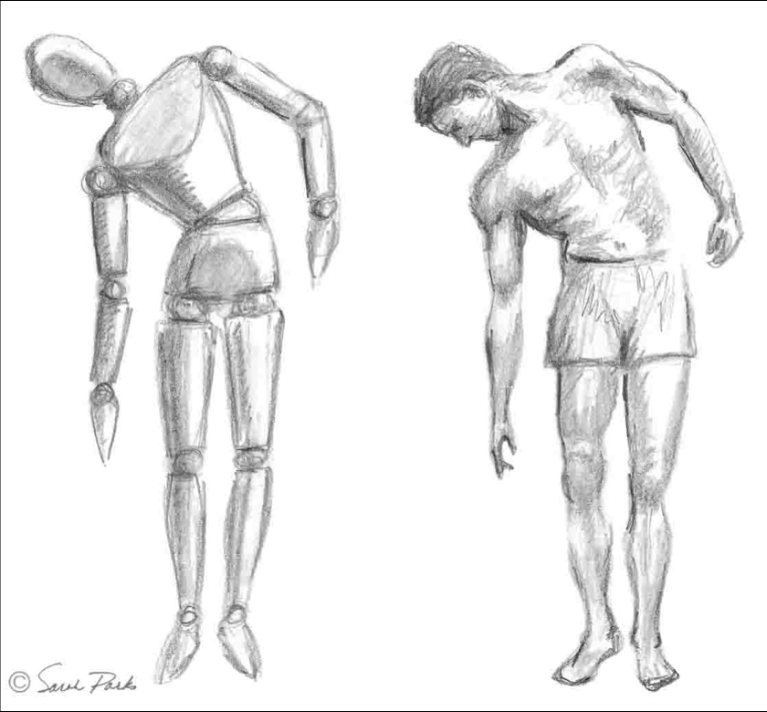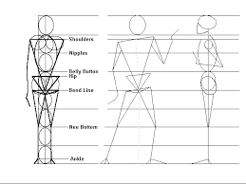 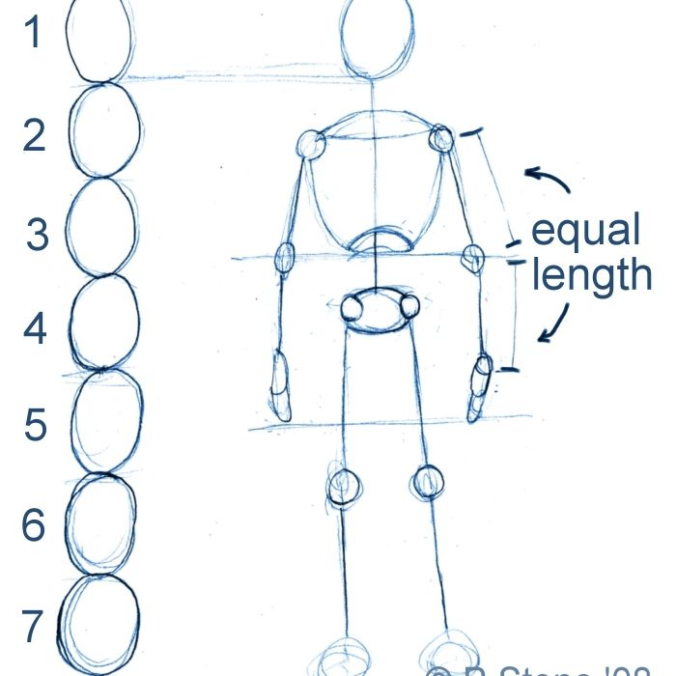

Once you have the proportions right—that’s the physical structure—you can go on and move the body around to get the perspective you need and add all the nice shading and detail work to make it look like a person instead of circles. But if you screw up the proportions and the head is 1.5times too big, no amount of fine shading is going to make it look right. I think the analogy is pretty clear, but in case it’s not: **I want to focus on writing simple, basic, and explicitly structured now**. Once it’s clear your structure is sound, we can dress it up and even soften the “directness” of statements to make it more elegant and pleasing. Trying to go from ideas in your head to a Michelangelo of a manuscript is not advised.